Optical Image Encryption Based on Input Plane and Fourier Plane Random Encoding

SUBMITTED BY
YASH KHARETA (21BSD004)
UNDER THE SUPERVISION OF
DR. SAVITA ANJANA



CERTIFICATE

Presented on 22-11-2023
This project involved the utilization of Fourier Encoding techniques to process and manipulate optical images. The recipient has shown exceptional understanding and application of concepts related to optical image processing through Fourier encoding methodologies.
This project was completed under the guidance of DR. Savita Anjana and has been evaluated in accordance with the standards set forth by THE NORTHCAP UNIVERSITY .
Signature: ____________________ [DR. SAVITA ANJANA]
Date: ___22-11-2023____________

Table of Contents

Abstract
Image Encryption
Optical Image
Optical image encryption
Different types of Encryption methods
Fourier Encoding
My Work

Abstract

Growing with the fast evolution of digital data exchange, security information becomes much important in data storage and transmission. Due to the increasing use of images in industrial process, it is essential to protect the confidential image data from unauthorized access. The security system based on the fractional Fourier transform (FRFT) is protected by only a certain order of FRFT. In this paper, we proposed a novel method to encrypt an image by using Discrete Fourier Transform (DFT) and Fractional Fourier Transform (FRFT). In this paper, we analyze the image encryption using DFT and FRFT based on double random phase matrix. The implementation of both techniques has been realized for experimental purposes. Detailed results in terms of security analysis and implementation are given. Comparative study with traditional encryption algorithms is shown the superiority.

Authors of the Research Paper

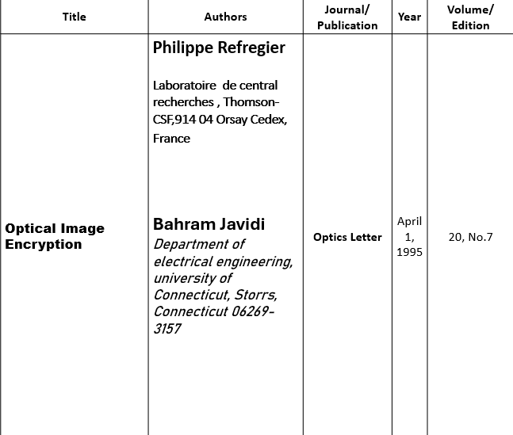

Introduction

In the development of digital technology and computer industry, the requirements for information confidentiality has attracted increasing attention. In order to provide protection to multimedia applications, many algorithms have been developed during the past several decades. The application of optical methods in information security has become a hot trend due to its inherent capabilities of parallel processing [1,2,3,4,5]. The classic double random-phase encoding was proposed based on an optical Fourier transform system. Subsequently, a large number of approaches have been developed to searching for other types of optical encryption methods in different domains, such as fractional Fourier domain [6,7,8], Fresnel domain [9,10] and gyrator domain [11]. However, due to inherent symmetry and linearity, the security of such cryptosystems is greatly affected [12,13]. During the process of optical image encryption, it is necessary not only to conceal the information of whole image, but also to selectively encrypt the important information, so as to improve local security. In addition, considering the characteristics of chaotic systems (i.e., sensitivity to initial values, deterministic dynamics, nonlinear transformation and pseudo-randomness) [14,15], applying chaotic systems to optical image encryption may have a positive impact on the overall security.

Experimental Results and Security Analysis

The numerical simulation and security verification of the algorithm are performed by Matlab R2017a. A standard grayscale image Lena of size 512×512 is shown in Figure 9a is the original image. The initial values and system parameters of the algorithm are m=2, x1(1)=0.1, x2(1)=0.1, x3(1)=0.1, u0=0.1, γ=−250, k=−0.6, z=−0.1, h=0.01, n=14, s=0.1, ρ=632.8 nm, d1=40 mm, d2=50 mm, α=3, β=5, respectively. In addition, two prime numbers (p=257 and q=311) are applied in the RSA cryptosystem to obtain public key (N=79,927, e=6937) and private key (d=4393). Figure 9b shows the encrypted grayscale image Lena, and the decrypted image with correct keys is shown as Figure 9c.
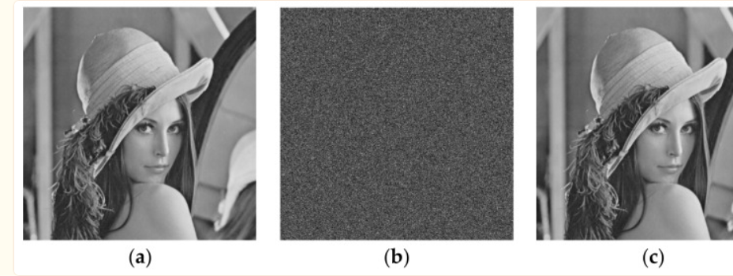

Security Analysis

Key Space Analysis
In this work, the precision of noninteger key is considered as 10−16. This algorithm covers a chaotic Hopfield neural network with 3 noninteger initial values, fuzzy single neuronal dynamic system with 7 noninteger initial values and other system parameters. Thus, the key space is larger than 2128, which is enough to resist brute force attacks [46,47].

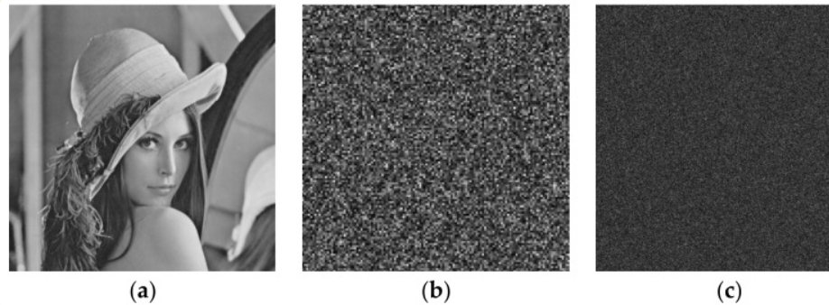

Correlation Analysis
Due to the discernibility of information in plaintext images, adjacent pixels are usually highly correlated. Therefore, the reduction of the correlation between adjacent pixels of the cipher images is necessary [48]. The calculation of pixel correlation is shown as Equation (21).
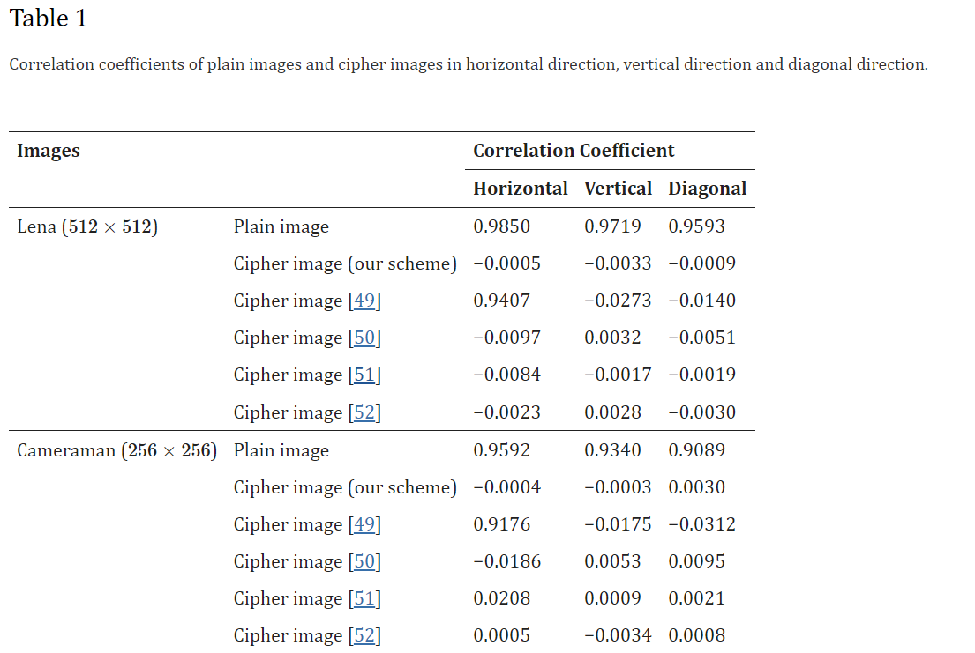

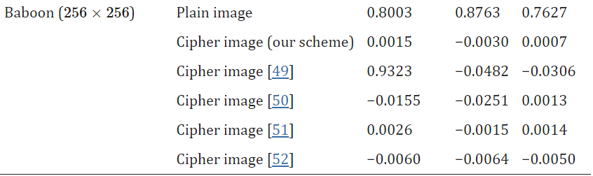

It should be noted that the scheme combines double random phase encoding in 4f system and Fresnel domain with Hopfield neural network to address inherent limitation of random matrix construction. The correlation coefficients of four encrypted images using various schemes are also demonstrated in Table 1. It can be seen that our method reaches relatively low correlation coefficients compared with other methods, which indicates that the integration of double random phase encoding and Hopfield neural network can achieve better performance.

Histogram Analysis
Histogram analysis is the statistic of the number of times each value appears, in order to demonstrate the distribution of pixel values [26]. The histogram of cipher image should not reflect any information about the original image. Figure 12 shows the histogram analysis of four images. It can be seen that the histograms of encrypted test images approximate Rayleigh distribution function, therefore the frequency distribution of plaintext images is hidden.

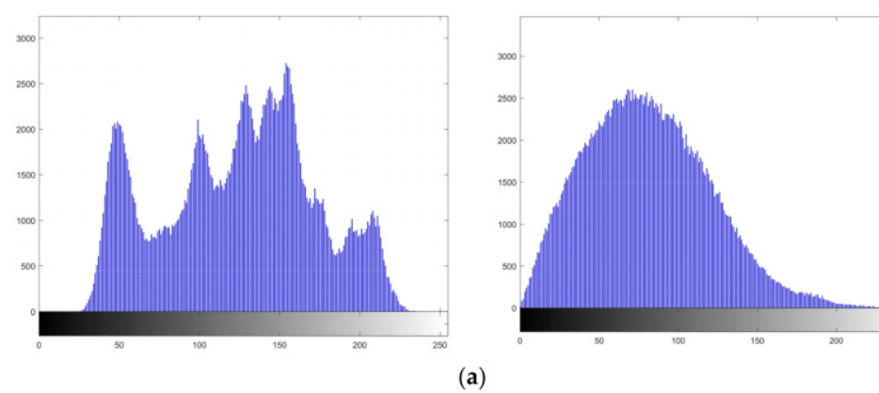

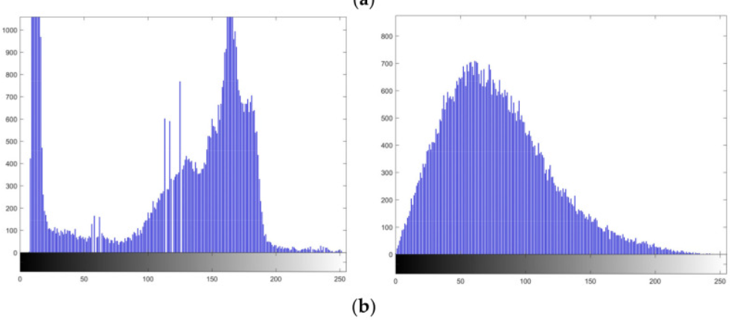
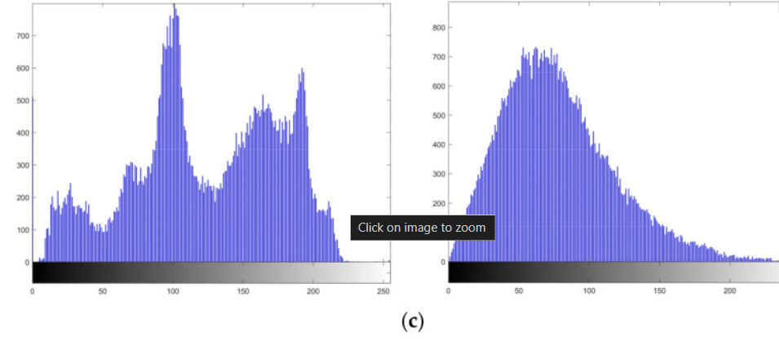

Binary Image Test
Due to the simple content of binary images, the traditional methods are not applicable sometimes. To test the performance of the algorithm on binary images, the results of encryption are shown in Figure 13. It can be seen that our algorithm works well on binary images, and the correlation coefficients of cipher images are listed in Table 2.

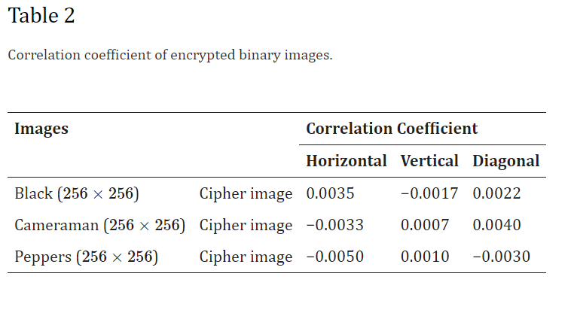

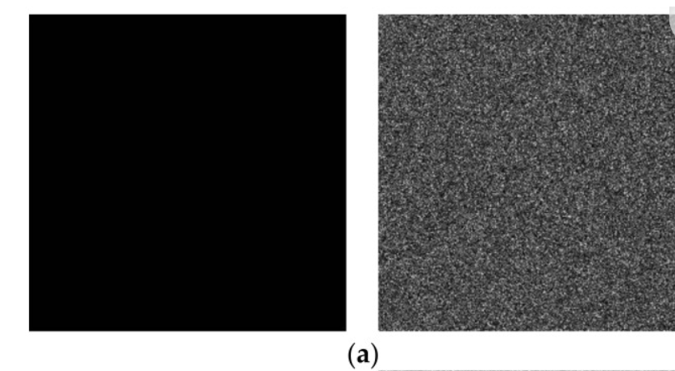

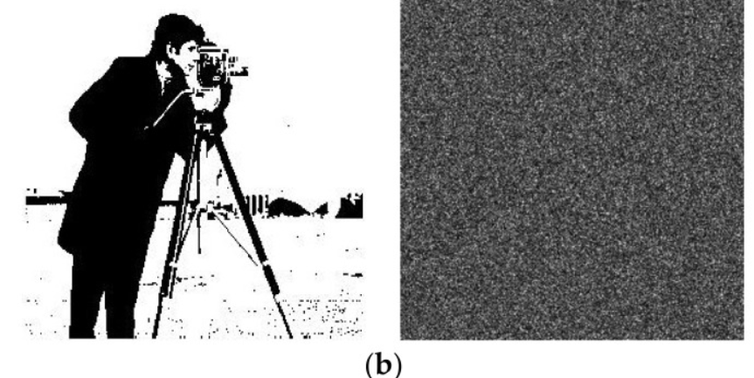
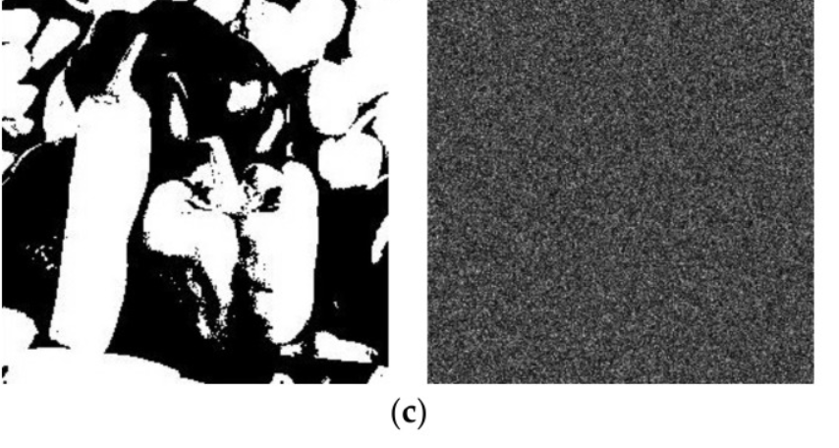

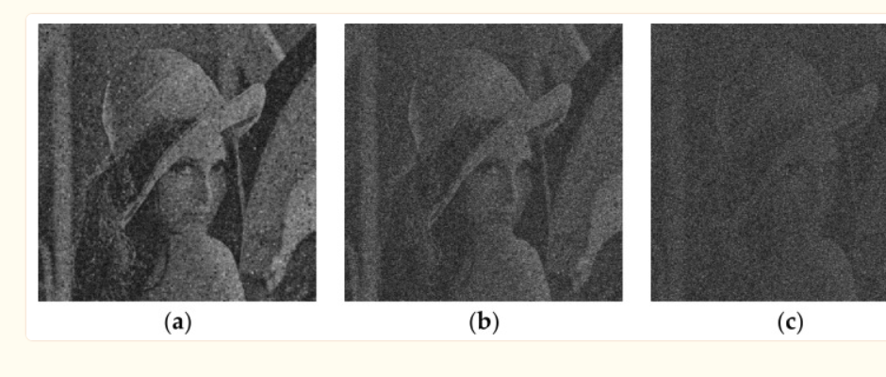

Conclusions
This paper proposes an optical image encryption method using double random-phase encoding in 4f system and Fresnel domain based on chaotic system. The chaotic sequences are constructed by applying a fuzzy single neuronal dynamic system and a Hopfield chaotic neural network. The plaintext image is decomposed into sub-signals by wavelet packet transform, and then the sub-signals are scrambled. By adaptive classification, the sub-signals are divided into two layers. The first layer and second layer are encrypted in 4f system and Fresnel domain, thus completing the hybrid encryption. After inverse wavelet packet transform, the encrypted image is obtained through another scrambling. The RSA cryptosystem is applied to the allocation and management of the keys used in the scheme. Numerical simulations have demonstrated the security and effectiveness of the proposed scheme. The suggested scheme implements selective encryption of the local image, which improves the protection efficiency of vital information. It should be noted that the fuzzy numbers effectively enhance the stability and key space of the single neuronal dynamic system, and different fuzzy numbers other than triangular may be applicable to more chaotic systems.

References

Alfalou A., Brosseau C. Optical image compression and encryption methods. Adv. Opt. Photonics. 2009;1:589–636. doi: 10.1364/AOP.1.000589. [CrossRef] [Google Scholar]
2. Shi Y., Li T., Wang Y., Gao Q., Zhang S., Li H. Optical image encryption via ptychography. Opt. Lett. 2013;38:1425–1427. doi: 10.1364/OL.38.001425. [PubMed] [CrossRef] [Google Scholar]
3. Gong L., Deng C., Pan S., Zhou N. Image compression-encryption algorithms by combining hyper-chaotic system with discrete fractional random transform. Opt. Laser Technol. 2018;103:48–58. doi: 10.1016/j.optlastec.2018.01.007. [CrossRef] [Google Scholar]
4. Yao L., Yuan C., Qiang J., Feng S., Nie S. An asymmetric color image encryption method by using deduced gyrator transform. Opt. Lasers Eng. 2017;89:72–79. doi: 10.1016/j.optlaseng.2016.06.006. [CrossRef] [Google Scholar]
5. Liansheng S., Xiao Z., Chongtian H., Ailing T., Asundi A.K. Silhouette-free interference-based multiple-image encryption using cascaded fractional Fourier transforms. Opt. Lasers Eng. 2019;113:29–37. doi: 10.1016/j.optlaseng.2018.10.002. [CrossRef] [Google Scholar]

